FOR IMMEDIATE RELEASE

Compact Stepper Driver/Controller Module ready for integration
Liberty Hill, Texas – October 2018
Texas-based company AccelMotion® today announced the DC2C Step Motor Driver/Controller, which extends the DC-Series of step-motor driver/controllers with a chassis-mounted 2A model.
The compact but rugged DC2C integrates a powerful efficient driver with an easy-to-use feature-rich motion controller, configurable general-purpose inputs and outputs, diagnostic and protective circuits including a user-serviceable fuse; all powered by a single supply input. The DC2C provides stepper drive control with 2 Amps of drive current at up to 40V, interoperability with other DC-series controller/drivers allowing up to 32 axes of motion under a single hosts control, and language compatibility with products from sister company AMS as well as other AccelMotion products. Built-in monitoring circuits display supply voltage and operating driver temperature to the host, real-time.
David Smith, the CEO of AccelMotion stated “The DC2C provides a workhorse motion controller/driver for OEMs, designed and priced for integration. The configurable I/Os allow changes to function without rewiring, and the monitoring of faults and temperature lets the designer track operation.”
The DC2C is designed for integration in equipment destined for: laboratory materials handling, packaging, testing, factory automation, and other motion-control applications.
For more information, email the company at: sales@accelmotion.com or call at 512-212-7300.
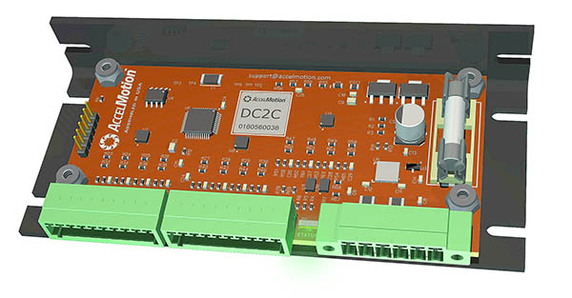

About AccelMotion
AccelMotion and its sister company Advanced Micro Systems/AMS are located in Liberty Hill, Texas, USA. The AMS family of companies has been in the business of motion control subsystems since 1983.

